What is the

TIC module?

& what are the related technologies related to it?

Word, PowerPoint, excel, latex, Html & CSS, Git and GitHub…

All those technologies are educated in this module, and in the next pages you will learn more about it.

Work prepared by:

* Rafie BAZINE
* Yacine GHERBI
* Kahina SLIMANI
* Sofiane HAMAIDI

L1 SIGL, USTHB.

31 december 2023.

Content Table

What is TIC? 3

Microsoft Technologies 4

PowerPoint 5

Excel 5

Alternatives 6

LaTex 7

Comparison between Microsoft word and Latex: 8

Html & CSS 9

Git & GitHub 10

Git 10

GitHub 10

# What is TIC?

TIC is and abbreviation of “ Information and Communication Technologies ”.

this Module teaches us the fundamentals of office works and technologies such us **Word** and **excel** and **PowerPoint**, and also the fundamentals of web development which are **HTML & CSS** and the essentials of collaborative work with **Git** **& GitHub.**

Our professor in this module is:

Mr. Redouane BOUCHEKIR

# Microsoft Technologies

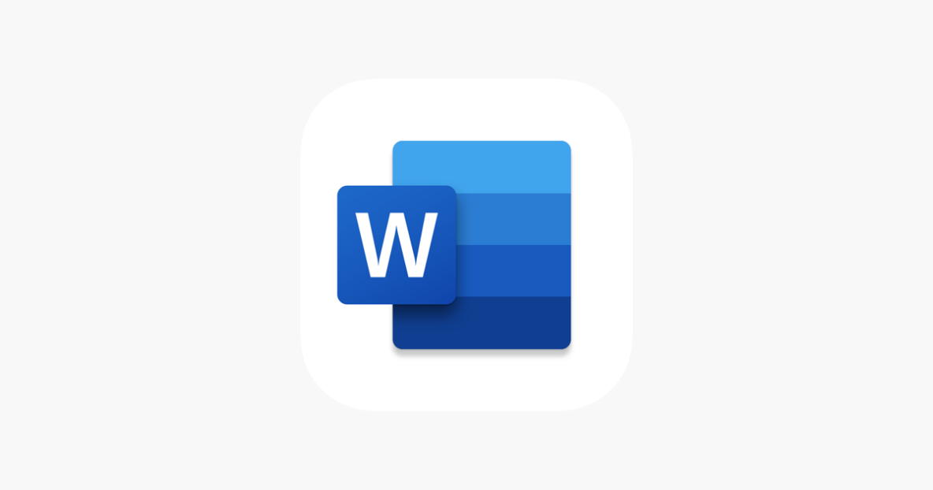Word

Description:

Microsoft Word, launched in 1983, is a pivotal word processing tool developed by Microsoft. Originally designed for MS-DOS and later adapted for Windows, Word is integral for document creation and editing. Noteworthy features include extensive formatting options, pre-designed templates, real-time collaboration tools, and robust review functions, catering to diverse document needs from reports to collaborative projects.

Key Features:

1. **Word Processing:** Comprehensive tools for document creation and editing.
2. **Formatting Options:** Diverse styling choices for fonts, styles, and layouts.
3. **Templates:** Pre-designed templates for various document types.
4. **Collaboration Tools:** Real-time collaboration and editing by multiple users.
5. **Review Functions:** Spell-checking, grammar checking, and change tracking.

## PowerPoint

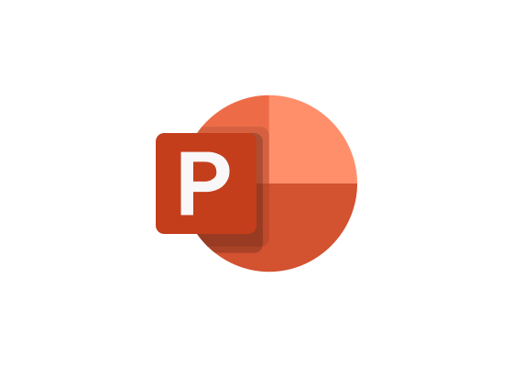Description:

Microsoft PowerPoint, introduced in 1987, revolutionized presentations. Initially for Macintosh and later Windows, it organizes content into visually appealing slides. With features such as pre-designed themes, animations, multimedia integration, and presenter view, PowerPoint facilitates dynamic and engaging presentations, making it a staple in business, education, and various communication scenarios.

Key Features:

1. **Slides:** Structured organization of content for presentations.
2. **Themes:** Pre-designed templates for consistent visual appeal.
3. **Animations:** Slide transitions and object animations for dynamic presentations.
4. **Multimedia Integration:** Embedding images, videos, and audio.
5. **Presenter View:** Allows speakers to view notes while presenting.

## Excel

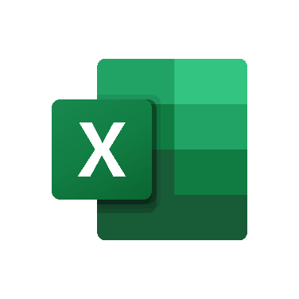Description:

Microsoft Excel, launched in 1985, is a robust spreadsheet program initially designed for Apple Macintosh and later adapted for Windows. Excel excels in data organization and analysis with features like grids, formulas, charts, and collaboration tools,

making it indispensable for tasks ranging from budgeting to collaborative project tracking.

Key Features:

1. **Spreadsheets:** Grid-based organization of data for analysis.
2. **Formulas and Functions:** Supportscomplex calculations and data analysis.
3. **Charts and Graphs:** Creates visual representations of data.
4. **Data Sorting and Filtering:** Efficient organization and manipulation of data.
5. **Collaboration Tools:** Enables multiple users to work on the same spreadsheet simultaneously.

## Alternatives

1. **Google Workspace tools: Sheets, Docs, Slides.**
2. **WPS office**
3. **Libre office**

# LaTex

Description:

LaTeX, developed in the 1980s by Leslie Lamport, is a typesetting system widely used in academia and science. It excels in producing high-quality documents with precise formatting, especially in mathematical and technical contexts. Known for its structured approach to document preparation, LaTeX integrates seamlessly with version control systems like Git and enjoys active community support.

Key Features:

1. **Typesetting:** High-quality document preparation with precise formatting.
2. **Mathematical Typesetting:** Strong support for mathematical symbols and equations.
3. **Structured Documents:** Efficient handling of complex documents.
4. **Version Control Integration**: Often used in conjunction with Git.
5. 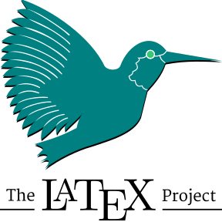**Community and Packages:** Active community support with numerous packages for extended functionality.

## Comparison between Microsoft word and Latex:

|  |  |  |
| --- | --- | --- |
| **Feature** | **LaTeX** | **Word** |
| **Typesetting** | Superior typesetting for technical documents | Standard typesetting for general use |
| **User Interface** | Markup-based, may require coding skills | What You See Is What You Get |
| **Document Structure** | Structured with commands and environments | Linear structure with sections and styles |
| **Math Support** | Excellent for mathematical notation | Good, but LaTeX excels in complex math |
| **Collaboration** | Challenging for non-LaTeX users | Seamless collaboration, track changes |
| **Customization** | Highly customizable | Customizable with templates and styles |
| **Version Control** | May integrate with Git easily | Limited version control capabilities |
| **Cost** | Open-source and free | Part of Microsoft Office, subscription-based |

# Html & CSS

Description:

HTML (Hypertext Markup Language), introduced in 1991, and CSS (Cascading Style Sheets), developed in the late 1990s, form the foundation of web development. HTML defines the structure and elements of a web page, while CSS separates presentation from content. Their combined features include markup language, hyperlinks, multimedia embedding, style definitions, layout control, and responsive design, ensuring a consistent web experience.

Key Features:

1. HTML:
   1. **Markup Language:** Defines the structure and elements of a web page.
   2. **Hyperlinks:** Allows navigation between pages and resources.
   3. **Multimedia Embedding:** Supports images, videos, and audio.
2. CSS:
   1. **Style Definitions:** Separates presentation from HTML by defining styles.
   2. **Layout Control**: Positions and sizes elements on a web page.
   3. **Responsive Design:** Ensures a consistent experience across different devices.

# Git & GitHub

## Git

Description:

Git, created by Linus Torvalds in 2005, is a distributed version control system transforming source code management. It tracks changes, supports branching, commits, and merging, enabling parallel development. Widely adopted for its robust version control capabilities, Git is instrumental in maintaining code integrity and collaboration in software development.

Key Features:

1. **Version Control:** Tracks changes in source code over time.
2. **Branching:** Allows for parallel development and experimentation.
3. **Commits:** Records changes with comments for clarity.
4. **Merging:** Combines changes from different branches.



## GitHub

Description:

GitHub, founded in 2008, is a collaborative platform hosting Git repository. It enhances Git's capabilities with features like repository hosting, collaboration tools, code review, and integration with CI/CD tools. GitHub's user-friendly interface and social coding aspects make it a central hub for open-source projects, facilitating seamless collaboration and code contribution.

Key Features:

1. **Repository Hosting:** Provides a platform for hosting Git repositories.
2. **Collaboration Tools:** Facilitates teamwork through issues, pull requests, and discussions.
3. **Code Review:** Enables collaborative code review with comments and suggestions.
4. **Continuous Integration:** Integrates with CI/CD tools for automated testing and deployment.